

SERCO of Texas, Inc.

Request for Proposal (RFP)

for

Office Space

Release Date: February 9th, 2026, at 11:00 AM CST
Response Due: February 27th, 2026, 11:00 AM CST

SERCO of Texas, Inc.
9301 Michigan Ave
Detroit, MI 48210
www.sercooftexas.com

SERCO of Texas is an Equal Opportunity employer/program. Historically Underutilized Businesses (HUB’s) are encouraged to apply. Auxiliary aids and services are available upon request to individuals with disabilities. Telephone access is available by dialing 711 or you can also call (512) 936-0342; (TDD): 1-800-735-2989, Voice 1-800-735-2988.

Table of Contents
- Introduction..........................................................................................................................
- About Serco of Texas...........................................................................................................
- Availability of RFP and Proposal Instructions.................................................................
- Scope of Work......................................................................................................................
- Space Requirements
- Parking
- Building Class
- Location
- Lease Terms
- Submission Requirements...................................................................................................
- Property Information
- Lease Terms
- Compliance and Documentation
- Contact Information
- Evaluation Criteria and Evaluation Process.....................................................................
- Proposal Submission Process..............................................................................................
- Timeline and Important Dates............................................................................................
- Disclaimer.............................................................................................................................
- Attachment ..........................................................................................................................
- Attachment A (PROPOSAL COVERSHEET)
- Attachment B (CERTIFICATION REGARDING CONFLICT OF INTEREST)
- Attachment C (CERTIFICATION REGARDING DEBARMENT, SUSPENSION, OTHER RESPONSIBILITY MATTERS)
- Attachment D (ADDITIONAL DOCUMENTATION FORM)
- Attachment E (Property Information & Location Details)

- About SERCO of Texas
SERCO of Texas (SERCO) provides workforce development services, operating in multiple Texas workforce development board areas: South Texas (one-stop and childcare), Brazos Valley (childcare), Alamo (rural youth), Heart of Texas (one-stop), Concho Valley (one-stop and childcare), and the Gulf Coast (one-stop). SERCO delivers a wide range of programs, including the Workforce Innovation and Opportunity Act (WIOA) Adult, Dislocated Worker, and Youth programs, Temporary Assistance for Needy Families (TANF/Choices), Supplemental Nutrition Assistance Program Employment & Training (SNAP E&T), Employment Services (ES) Non-Custodial Parent (NCP) program, and National Emergency Grants (NEG).
- Purpose of RFP
In collaboration with Arvo Realty Advisors, SERCO of Texas is seeking to lease fully furnished office space in the Houston, Texas area. We are soliciting competitive proposals from landlords or property owners for a space that meets our operational needs. The ideal location would offer up to 10,000 square feet of office space in a Class A or B building (Asset Type: Retail, Office, Flex Space), with flexibility for smaller space, with sufficient parking and immediate availability to accommodate approximately 50 to 100 employees & Clients. SERCO of Texas is currently funded through the Houston-Galveston Area Council (H-GAC) within the Houston-Gulf Coast Workforce Development Area.
- Availability of RFP and Proposal Instructions
The complete Request for Proposal (RFP) and detailed proposal instructions can be accessed through the SERCO of Texas (SERCO) website at:
- Website: https://www.sercooftexas.com
Interested parties can download the RFP directly from the website. All proposal submissions must follow the guidelines provided in the RFP document. Proposals must include all required documentation and meet the specified criteria outlined within the RFP. Failure to adhere to these instructions may result in disqualification.
Key instructions include:
- Submission Format: Proposals must be submitted in PDF format.
- Deadline: Proposals must be submitted via email by Friday February 27th, 2026, at 11:00 AM CST
- Required Documents: Include property details, lease terms, proof of compliance, and any other supporting documents as specified in the RFP.
**Interested landlords or property owners may submit proposals for one or multiple office space options**

For further information, please contact SERCO at:
- Email: Ktaveras@sercohq.com | Katherine Taveras, Administrative Coordinator, SERCO of Texas

- Scope of Work
SERCO requires the following for the office space:
Space Requirements: The ideal space shall be move-in ready, fully built out, and suitable for immediate occupancy, requiring no construction, renovations, or tenant improvements, and consisting of up to 10,000 square feet, with flexibility for smaller space.
- Reception area
- 1–2 conference rooms
- At least one large training room
- Up to 10 private offices
- Open workspace for cubicles
- Breakroom and ADA-compliant (Restrooms, Exit and Entrance, ETC..)
Expansion options should be available to meet potential future needs.
- Parking: The building must provide a minimum of 3 parking spaces per 1,000 square feet.
- Building Class: The space should be located in a Class A or B building (Asset Type: Retail, Office, Flex Space).
- Location: The property must be situated in ZIP code 77338, in close proximity to US-59, to ensure access to public transportation, major highways.
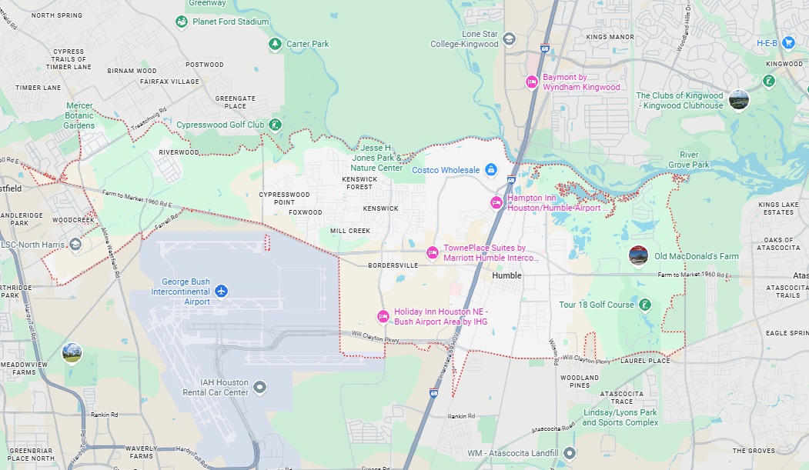
- Lease Terms: All proposed lease arrangements must qualify as an operating lease and may not constitute a capital lease as defined under applicable federal and state cost principles, including 2 CFR Part 200 and H-GAC Contract Management Standards
Proposals should include the following:
  - Lease term (up to five (5) years, with optional renewal periods at SERCO of Texas’ sole discretion). The lease must not include any provision that transfers ownership, includes a bargain purchase option, or otherwise constitutes a capital lease
  - Base monthly rent (inclusive of property taxes, maintenance charges, and any applicable fees)
  - Leasehold improvement allowance (if available)
  - Annual rent escalation (if applicable)
Move-In Readiness, Lease Term, and Maintenance Responsibilities
  - SERCO of Texas prefers office space that is move-in ready or would require no or minimal build-out.
  - SERCO of Texas is willing to enter into a lease term of up to five (5) years, subject to funding availability and required approvals.
  - Lease provisions must include an early termination clause, without penalty, in the event SERCO of Texas experiences a reduction or loss of public funding.
  - The owner/landlord shall be responsible for all repair and maintenance of the facility, including but not limited to plumbing, HVAC, roof, foundation, flooring, and other structures or equipment serving the facility.
  - Such costs shall not be the responsibility of SERCO of Texas.

Connectivity & Technology Readiness: The proposed space should be capable of supporting standard office technology and connectivity needs, including reliable access to internet and telecommunications services. The space should have existing infrastructure in place to allow for timely activation of services, without requiring major construction, structural modifications, or extensive build-out.
An example floor plan is provided as an exhibit (see Exhibit A) for illustrative purposes only to demonstrate the general layout and functional configuration sought by SERCO of Texas. This example is intended as a conceptual model and does not represent a required or exact layout. Proposed spaces are not required to match the example floor plan and may vary in design, configuration, and square footage, provided they meet the overall functional requirements outlined in this RFP

- Submission Requirements
Interested landlords or property owners may submit proposals for one or multiple office space options and must include the following information with their proposal:
- Property Information:
  - Building name and address
  - Class of building (A or B)
  - Total square footage available (up to 10,000 square feet, with flexibility for smaller space).
  - Floor plans and photographs of the property
- Lease Terms:
  - Proposed lease term
  - Base rent and additional fees (e.g., parking, maintenance, utilities)
  - Parking space availability and cost (if separate)
  - Leasehold improvement allowance (if applicable)
- Compliance and Documentation:
  - Proof of building's compliance with local zoning and regulatory requirements
  - Any available certifications (e.g., ADA compliance, energy efficiency, Certification of Occupancy)
  - Americans with Disabilities Act (ADA) Compliance, including:
    - The building must comply with the ADA and all applicable amendments
    - Owner/landlord must provide and maintain all required accessibility accommodations, including ramps, accessible entrances and exits, door hardware, signage, and restrooms
    - All rooms and hallways must meet ADA accessibility requirements
    - All restrooms must meet ADA accessibility standards, with a minimum of two sets of restrooms or restrooms of sufficient size to accommodate staff and the public
    - If provided, elevators must be ADA-compliant
- Contact Information:
Provide the name, phone number, and email address of the property manager or leasing agent authorized to respond to this RFP.
- Evaluation Criteria and Evaluation Process
The evaluation process will consist of:
- An initial review of responsiveness and compliance with the technical specifications and other criteria specified in the RFP by the SERCO and ARVO staff.
- All responsive proposals will be evaluated and scored by an internal team of reviewers. Proposals will be evaluated on specific criteria by reviewers using a standardized instrument.
- Presentation of scoring and recommendations to the SERCO of Texas CEO.
Proposers must achieve an overall score of at least 70 points to be considered for the award. The review and evaluation of proposals shall be based upon the following criteria:
Evaluation Criteria | Description | Max Score
Location and Accessibility | Proximity to public transportation and ease of access for employees and clients and alignment with the designated service area zip codes, as identified elsewhere in this RFP. | 20
Space Specifications | Compliance with space requirements, including the availability of furnishings and parking | 30
Lease/Rental Terms | Reasonableness of base rent, length of lease, and any additional charges or incentives | 30
Suitability of Premises | Condition of the premises, overall building quality (Class A or B), and suitability for SERCO’s operational needs | 20
HUB Certification | Additional points for current HUB certification | 5
Overall Score | Total score | 105
**The maximum total score available is 105 points**

Arvo Realty Advisors may provide technical and market-based advisory support during the evaluation and negotiation process; however, final scoring, selection, and approval authority remains with SERCO of Texas.
- Proposal Submission Process
All proposals must be submitted by Submission Deadline: February 27th, 2026, 11:00 AM CST via email to the following:
- To Email: Ktaveras@sercohq.com | Katherine Taveras, Administrative Coordinator, SERCO of Texas
Late proposals or those missing required information will not be considered. Ensure that all required documents are attached and submitted in PDF format.

Questions:
No pre-bid or pre-proposal conference will be held for this solicitation. All questions regarding this RFP must be submitted in writing via email to ktaveras@sercohq.com by Thursday, February 19, 2026, no later than 3:00 PM (CST). Responses to all questions received by the deadline will be compiled and shared with all known proposers to ensure fairness and transparency.
Responses to all questions received by the deadline will be compiled and sent to all known proposers by Monday, February 23, 2026, to ensure fairness and transparency.

- Timeline and Important Dates
- RFP Issue Date: February 9th, 2026, at 11:00 AM CST
- Questions Due Date: Thursday, February 19, 2026, 3:00 PM (CST)
- Questions Response: Monday, February 23, 2026, 3:00 PM (CST)
- Proposal Submission Deadline: February 27th, 2026, 11:00 AM CST
- Disclaimer
SERCO of Texas (SERCO) reserves the right to reject any or all proposals that do not meet the specified requirements. This RFP does not commit SERCO to any financial obligations or guarantee the lease of any property until all negotiations are finalized and a lease agreement is executed. Selection of a proposed space and execution of any lease is subject to compliance with all applicable federal and state requirements and final approval by the Houston-Galveston Area Council (H-GAC) and, if required, the Texas Workforce Commission (TWC). SERCO of Texas reserves the right to withdraw from lease negotiations if required approvals are not obtained.”
SERCO of Texas is an Equal Opportunity employer/program. Historically Underutilized Businesses (HUB’s) are encouraged to apply. Auxiliary aids and services are available upon request to individuals with disabilities. Telephone access is available by dialing 711 or you can also call (512) 936-0342; (TDD): 1-800-735-2989, Voice 1-800-735-2988.

ATTACHMENT A
PROPOSAL COVERSHEET REQUEST FOR PROPOSAL

OFFICE SPACE

Legal Name of Proposing Entity
Mailing Address

Authorized Contact/Signatory Authority

Phone Number
E-Mail
Type of Organization | □Private for-profit  □Private non-profit  □Government Agency  □Partnership  □Sole Proprietor  □Other (specify)
Date Established
Federal EIN
Texas State Comptroller ID Number
Historically Underutilized Business? | □Yes (if yes, attach current certificate)  □No
Typed Name & title of Authorized Signatory

Signature

ATTACHMENT B
CERTIFICATION REGARDING CONFLICT OF INTEREST
By signature of this proposal, Proposer covenants and affirms that:
- no manager, employee or paid consultant of the Proposer is a member of the SERCO of Texas, Inc., the Executive Director, or an employee of the SERCO of Texas, Inc.
- no manager or paid consultant of the Proposer is married to a member of the SERCO of Texas, Inc., the Executive Director, or an employee of the SERCO of Texas, Inc.
- no member of THE SERCO OF TEXAS, INC, the Executive Director or employee of the SERCO of Texas, Inc. owns or controls more than a 10 percent interest in the Proposer.
- no spouse or member of the SERCO of Texas, Inc., Executive Director or employee of the SERCO of Texas, Inc. is a manager or. paid consultant of the Proposer.
- no member of the SERCO of Texas, Inc., the Executive Director or employee of the SERCO of Texas, Inc. receives compensation from Proposer for lobbying activities as defined in Chapter 305 of the Texas Government Code.
- Proposer has disclosed within the Proposal any interest, fact or circumstance which does or may present a potential conflict of interest.
- should Proposer fail to abide by the foregoing covenants and affirmations regarding conflict of interest, Proposer shall not be entitled to the recovery of any costs or expenses incurred in relation to any contract with the SERCO of Texas, Inc. and shall immediately refund to the SERCO of Texas, Inc. any fees or expenses that.
- May have been paid under the contract and shall further be liable for any other costs incurred or damages sustained by SERCO of Texas, Inc. relating to that contract.

Disclosure of Potential Conflict of Interest______________________________
Name of Applicant Organization: _______________________________________
Name of Authorized Signatory: _________________________________________
Title of Authorized Signatory: ____________________________________________
Signature________________________________ Date: ________________________
ATTACHMENT C
CERTIFICATION REGARDING DEBARMENT, SUSPENSION, OTHER RESPONSIBILITY MATTERS
This certification is required by the regulations implementing Executive Order 12549, Debarment and Suspension, 29 CFR Part 98, Section 98.150, Participants' responsibilities. The regulations were published as Part VII of the May 26, 1988, Federal Register (pages 19160-19211).
The prospective recipient of Federal assistance funds certifies, by submission of this proposal certifies the following:
- The organization or its principals are not presently debarred, suspended, proposed for debarment, declared ineligible, or voluntarily excluded from participation in this transaction by any Federal department or agency.
- Have not within a three-year period preceding this offer, been convicted of or had a civil judgment rendered against them for commission of fraud or a criminal offense in connection with obtaining, attempting to obtain, or performing a public (Federal, State, or Local) transaction or contract under a public transaction, violation of Federal or State antitrust statutes or commission under a public transaction, violation of Federal or State antitrust statutes or commission of embezzlement, theft, forgery, bribery, falsification or destruction or records, making false statements, or receiving stolen property;
- Are not presently indicted for or otherwise criminally or civilly charged by a governmental entity with commission of any of the offenses enumerated in Paragraph (2) of this certification; and
- Have not within a three-year period preceding this offer had one or more public transactions terminated for cause or default?
Where the prospective recipient of Federal assistance funds is unable to certify any of the statements in this certification, such prospective participant shall attach an explanation to this Proposal.
Name of Authorized Signatory: _________________________________________

Title of Authorized Signatory: ____________________________________________

Signature________________________________ Date: ________________________
Exhibit A

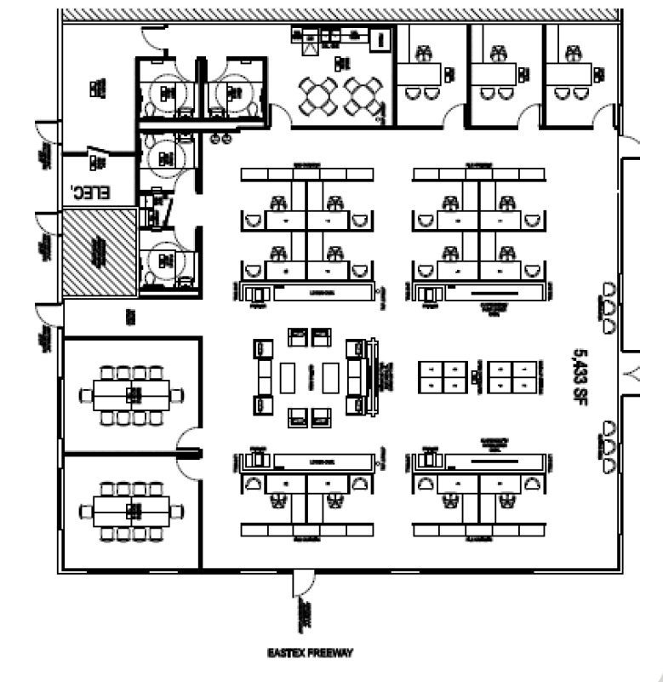
ATTACHMENT D
ADDITIONAL DOCUMENTATION FORM
Real Estate Licenses:
- Copies of current real estate licenses held by the agent or brokerage issued by the Texas Real Estate Commission (TREC).
Historically Underutilized Business (HUB) Certificate (If applicable)
- Attach a copy of the notice of certification issued by the Texas Comptroller of Public Accounts as a Historically Underutilized Business (HUB).
References:
Provide three (3) professional references for comparable office space leases, including contact name, title, phone number, and email address.

ATTACHMENT E
Property Information & Location Details
Disclaimer: If the Proposer intends to submit more than one property for consideration, a separate and complete Attachment must be submitted for each individual property. Properties submitted without a corresponding Attachment may not be considered.
Physical Address of Proposed Facility

Name of Building Owner

Name of Property Management Company, if applicable
Age of Facility | Year Built: ______________
Are there currently any tax or other types of liens against the said property. | ___ YES ___ NO If YES, identify:
Does the facility meet ADA requirements | ___ YES ____ NO
Does the facility have ADA bathrooms? How many bathrooms are in the space | ____ YES ____ NO ____ # of bathrooms
Is the elevators ADA compliant? | ____ YES ____ NO ____ N/A
Is the facility located in the required zip code area(s)? | ____ YES ____ NO
Is the facility near or convenient to a public transportation stop? | ---- YES ____ NO
Access to facility: Monday through Friday 7:00 a.m. to 6:30 p.m. | ---- Yes ____ No
Are employees able to enter/open the building at any time? | ---- YES ---- NO If NO, detail the procedure for off hours entry
SERCO requires space for 50 to employees and clients. The description of the facility needs is in Section: Scope of Work – Space Requirement | Total Square Footage: ___________
Square Footage Cost | $ ______________ per square foot
Floor Plan | Attached Copy
Other Occupants | List, if applicable, if building has any other existing occupants
Are there any insurance requirements? | Specify:
How many parking spaces are available. | _______
Building Maintenance/Repair/Utilities | Owner/Landlord willing to accept for repair and maintenance of roof, foundation, parking, plumbing, HVAC, structural soundness, other structures or equipment serving the facility, ceiling tiles, flooring, and any other items considered long-lived assets  ------ YES ---- NO  Owner/Landlord pays utility cost  ____ YES ____NO  Comments:
Terms of Lease- i.e., length, renewal, notices, escalation clauses, restrictions, etc.  May submit a draft copy of a lease agreement | Owner/Landlord willing to accept a five-year lease.  ---- YES ____ NO  Comments:
Do you agree with the provision that allows early termination (without penalty) should a major reduction or loss of public funding? | ---- YES ____ NO  Comments:
Would facility be ready by on or before August 1, 2026? | ---- YES ____ NO  If NO, estimate the date of availability of the facility
Provide any additional information you think to be an asset of this location.
Please attach any additional relevant information regarding this facility below:

